SPRINT 2

|  |  |
| --- | --- |
| **TEAM ID** | PNT2022TMID20858 |
| **PROJECT NAME** | Smart Farmer - IoT Enabled Smart Farming  Application |
| **Date** | 17 November 2022 |

IBM WATSON CLOUD:

**Give the credentials of your device in IBM Watson IoT Platform Click on connect**

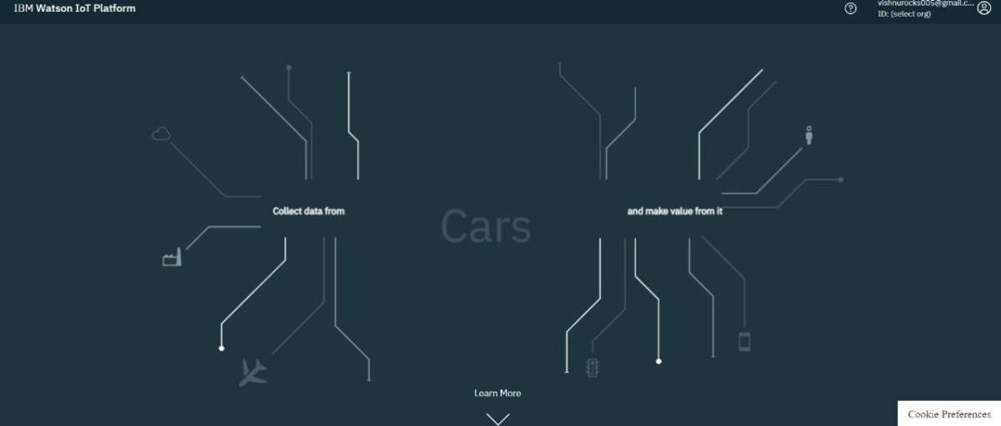**Device Id : 12345 Token : 12345678**

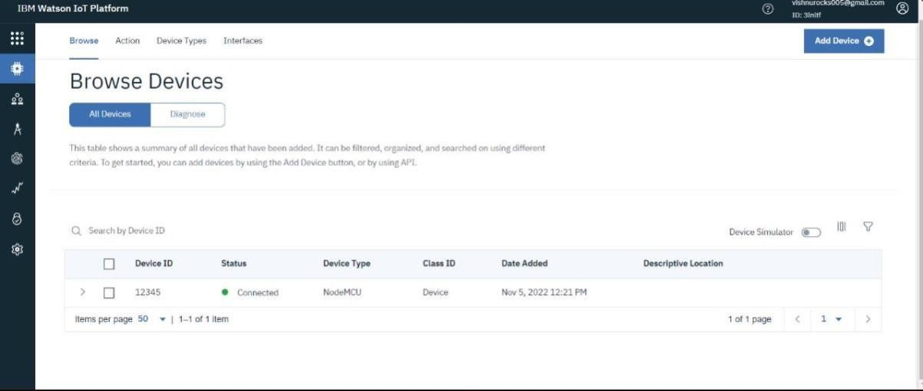

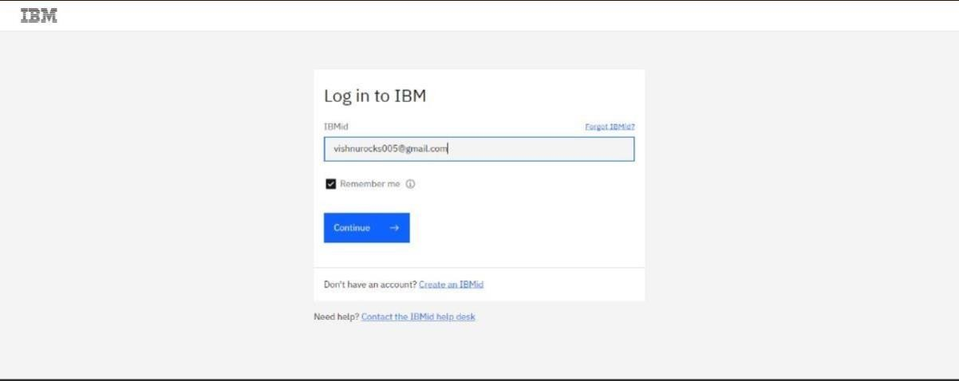

NODE – RED :

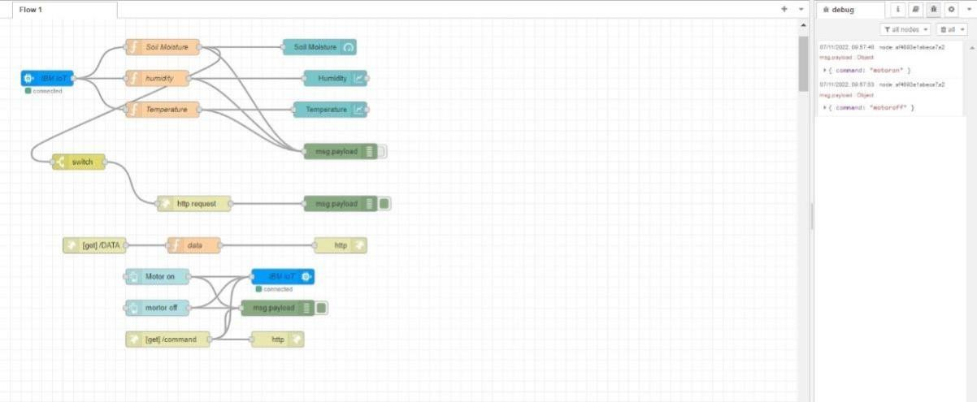**Nodes connected in following manner to get each reading separately**

[{"id":"55532a3a9414ada1","type":"tab","label":"Flow 1","disabled":false,"info":"","env":[]},{"id":"dd8948acf63987d6","type":"ibmiot in","z":"55532a3a9414ada1","authentication":"apiKey","apiKey":"64009416e5d88d75","inputTyp e":"evt","logicalInterface":"","ruleId":"","deviceId":"12345","applicationId":"","deviceType":"No

deMCU","eventType":"+","commandType":"","format":"json","name":"IBM IoT","service":"registered","allDevices":"","allApplications":"","allDeviceTypes":false,"allLogicalIn terfaces":"","allEvents":true,"allCommands":"","allFormats":"","qos":0,"x":90,"y":200,"wires":[[" cc5ee96d1fe8c0ec","4640bf220608c2b5","8878c5a96c8bd6c7"]]},{"id":"cc5ee96d1fe8c0ec","type ":"function","z":"55532a3a9414ada1","name":"Soil Moisture","func":"global.set('moist',msg.payload.soil_moisture)\nmsg.payload=msg.payload.soil

_moisture\nreturn msg;","outputs":1,"noerr":0,"initialize":"","finalize":"","libs":[],"x":330,"y":140,"wires":[["be4ecf dbd3805c1c","234da12208d57a19","823ed8368aa8fa6a"]]},{"id":"4640bf220608c2b5","type":"fu

nction","z":"55532a3a9414ada1","name":"humidity","func":"global.set('hum',msg.payload.humi dity)\nmsg.payload=msg.payload.humidity\nreturn msg;","outputs":1,"noerr":0,"initialize":"","finalize":"","libs":[],"x":300,"y":200,"wires":[["42e41d 121e826584","234da12208d57a19"]]},{"id":"8878c5a96c8bd6c7","type":"function","z":"55532a3a 9414ada1","name":"Temperature","func":"global.set('temp',msg.payload.temperature)\nmsg.pa yload=msg.payload.temperature\nreturn msg;","outputs":1,"noerr":0,"initialize":"","finalize":"","libs":[],"x":310,"y":260,"wires":[["e006a1 f31e1084f2","234da12208d57a19"]]},{"id":"42e41d121e826584","type":"ui_chart","z":"55532a3a 9414ada1","name":"","group":"32c77595865857f1","order":1,"width":"0","height":"0","label":"

Humidity","chartType":"line","legend":"false","xformat":"HH:mm:ss","interpolate":"linear","nod

ata":"","dot":false,"ymin":"","ymax":"","removeOlder":1,"removeOlderPoints":"","removeOlder Unit":"3600","cutout":0,"useOneColor":false,"useUTC":false,"colors":["#1f77b4","#aec7e8","#ff7f 0e","#2ca02c","#98df8a","#d62728","#ff9896","#9467bd","#c5b0d5"],"outputs":1,"useDifferentC olor":false,"x":640,"y":200,"wires":[[]]},{"id":"e006a1f31e1084f2","type":"ui_chart","z":"55532a3

a9414ada1","name":"","group":"32c77595865857f1","order":2,"width":"0","height":"0","label":"

Temperature","chartType":"line","legend":"false","xformat":"HH:mm:ss","interpolate":"linear","

nodata":"","dot":false,"ymin":"","ymax":"","removeOlder":1,"removeOlderPoints":"","removeOl derUnit":"3600","cutout":0,"useOneColor":false,"useUTC":false,"colors":["#1f77b4","#aec7e8","# ff7f0e","#2ca02c","#98df8a","#d62728","#ff9896","#9467bd","#c5b0d5"],"outputs":1,"useDiffere ntColor":false,"x":630,"y":260,"wires":[[]]},{"id":"be4ecfdbd3805c1c","type":"switch","z":"55532

a3a9414ada1","name":"","property":"payload","propertyType":"msg","rules":[{"t":"eq","v":"20"

,"vt":"str"}],"checkall":"true","repair":false,"outputs":1,"x":150,"y":360,"wires":[["6cc86205e442

77fb"]]},{"id":"0215325ab54b8d51","type":"debug","z":"55532a3a9414ada1","name":"","active": true,"tosidebar":true,"console":false,"tostatus":false,"complete":"payload","targetType":"msg"," statusVal":"","statusType":"auto","x":650,"y":440,"wires":[]},{"id":"6cc86205e44277fb","type":" http request","z":"55532a3a9414ada1","name":"","method":"GET","ret":"txt","paytoqs":"ignore","url ":"https://[www.fast2sms.com/dev/bulkV2?authorization=w3caxunBXmh5pO4KYsbdQEvAoS96UZ](http://www.fast2sms.com/dev/bulkV2?authorization=w3caxunBXmh5pO4KYsbdQEvAoS96UZ) 7tegHiGIN0yflLWr8JkjXAbmHyVvoj5SJGMlIs419xckpi0rwf&route=q&message=low%20soil%20moi sture%20level&language=english&flash=1&numbers=8870252283","tls":"","persist":false,"proxy"

:"","authType":"","senderr":false,"x":370,"y":440,"wires":[["0215325ab54b8d51"]]},{"id":"234da 12208d57a19","type":"debug","z":"55532a3a9414ada1","name":"","active":false,"tosidebar":tru e,"console":false,"tostatus":false,"complete":"false","statusVal":"","statusType":"auto","x":630,"

y":340,"wires":[]},{"id":"3ddbcc7ae9c17a4e","type":"function","z":"55532a3a9414ada1","name": "data","func":"msg.payload = {\n \"temperature\":global.get('temp'),\n \"humidity\": global.get('hum'),\n \"moisture\": global.get('moist')\n}\nreturn msg;","outputs":1,"noerr":0,"initialize":"","finalize":"","libs":[],"x":370,"y":520,"wires":[["72cb90 bf9a4ea129"]]},{"id":"72cb90bf9a4ea129","type":"http response","z":"55532a3a9414ada1","name":"","statusCode":"","headers":{},"x":650,"y":520,"wir es":[]},{"id":"a32037baad643597","type":"http in","z":"55532a3a9414ada1","name":"","url":"/DATA","method":"get","upload":false,"swaggerD

oc":"","x":180,"y":520,"wires":[["3ddbcc7ae9c17a4e"]]},{"id":"e9c894340e352161","type":"ui_bu

tton","z":"55532a3a9414ada1","name":"","group":"5a9be2a7.35e99c","order":0,"width":"3","hei ght":"2","passthru":false,"label":"Motor on","tooltip":"","color":"","bgcolor":"","icon":"","payload":"{\"command\":\"motoron\"}","payl

oadType":"json","topic":"","topicType":"str","x":300,"y":580,"wires":[["e00aec1775ab7ba1","af4 693e1abeca7a2"]]},{"id":"e00aec1775ab7ba1","type":"ibmiot out","z":"55532a3a9414ada1","authentication":"apiKey","apiKey":"64009416e5d88d75","output

Type":"cmd","deviceId":"12345","deviceType":"NodeMCU","eventCommandType":"cmd","forma t":"json","data":"data","qos":0,"name":"IBM IoT","service":"registered","x":540,"y":580,"wires":[]},{"id":"436ec2969a88e928","type":"ui_butt

on","z":"55532a3a9414ada1","name":"","group":"5a9be2a7.35e99c","order":1,"width":"3","heig ht":"2","passthru":false,"label":"mortor off","tooltip":"","color":"","bgcolor":"","icon":"","payload":"{\"command\":\"motoroff\"}","payl

oadType":"json","topic":"topic","topicType":"str","x":300,"y":640,"wires":[["af4693e1abeca7a2", "e00aec1775ab7ba1"]]},{"id":"af4693e1abeca7a2","type":"debug","z":"55532a3a9414ada1","na me":"","active":true,"tosidebar":true,"console":false,"tostatus":false,"complete":"payload","targ etType":"msg","statusVal":"","statusType":"auto","x":530,"y":640,"wires":[]},{"id":"dd8a9df81aa ebedf","type":"http in","z":"55532a3a9414ada1","name":"","url":"/command","method":"get","upload":false,"swag gerDoc":"","x":320,"y":700,"wires":[["05c851ba0d5bf5de","af4693e1abeca7a2","e00aec1775ab7 ba1"]]},{"id":"05c851ba0d5bf5de","type":"http response","z":"55532a3a9414ada1","name":"","statusCode":"","headers":{},"x":530,"y":700,"wir

es":[]},{"id":"823ed8368aa8fa6a","type":"ui_gauge","z":"55532a3a9414ada1","name":"","group"

:"2a4abd11.a253a2","order":0,"width":0,"height":0,"gtype":"gage","title":"Soil

Moisture","label":"units","format":"{{value}}","min":0,"max":"100","colors":["#00b500","#e6e60

0","#ca3838"],"seg1":"","seg2":"","x":650,"y":140,"wires":[]},{"id":"64009416e5d88d75","type":"

ibmiot","name":"API","keepalive":"60","serverName":"","cleansession":true,"appId":"","shared"

:false},{"id":"32c77595865857f1","type":"ui_group","name":"Default","tab":"5f4c2ea5.dc4e3","o

rder":3,"disp":true,"width":"6","collapse":false},{"id":"5a9be2a7.35e99c","type":"ui_group","na

me":"Default","tab":"5f4c2ea5.dc4e3","order":2,"disp":true,"width":"6","collapse":false},{"id":"2 a4abd11.a253a2","type":"ui_group","name":"Soil moisture","tab":"513e92a0.840a9c","order":1,"disp":true,"width":"8","collapse":true},{"id":"5f4c

2ea5.dc4e3","type":"ui_tab","name":"Home","icon":"dashboard","disabled":false,"hidden":false

},{"id":"513e92a0.840a9c","type":"ui_tab","name":"Home","icon":"dashboard","order":1,"disabl ed":false,"hidden":false}]